Declaration of Conformity (DoC)

We, Shenzhen Doke Electronic Co., LTD
801, Building3, 7th Industrial Zone, Yulv Community, Yutang Road, Guangming District, Shenzhen, China

Declare that the DoC is issued under our sole responsibility and belongs to the following product(s):

Product Type: | Smart Phone
Trademark： | Blackview / OSCAL
Model Number(s): | BL7000, PILOT 3, BL7000 Pro

(Name of product, type or model, batch or serial number)

(Name of product, type or model, batch or serial number)

System components:
PIFA Antenna:BT/Wi-Fi2.4G:2.2dBi; WIFI5G:2.7dBi;
GSM900: -1.58dBi/DCS1800: 0.76dBi; WCDMABandⅠ: 1.12dBi,BandⅧ: -1.58dBi;
LTE: Band 1: 1.12dBi; Band 3: 0.76dBi; Band 7: 1.61dBi; Band 8: -1.58dBi; Band 20: -1.57dBi;
Band 28: -1.93dBi; Band 40: 1.46dBi; Band 41: 1.54dBi
NR: N1: 1.12dBi; N3: 0.76dBi; N8: -1.58dBi; N20: -1.57dBi; N28: -1.93dBi;
N40: 1.46dBi; N41: 1.54dBi; N77: 2.21dBi;N78: 2.23dBi
Adapter :
Model: QZ-04501EC00
Input: 100-240V~50/60Hz 1.2A
Output: 5.0V 3.0A 15.0W or 9.0V 3.0A 27.0W
or 12.0V 2.5A 30.0W or 15.0V 2.0A 30.0W
or 20.0V 2.25A 45.0W Max
(PPS) 5.0V-11.0V 3.0A 33.0W Max
(PPS) 5.0V-20.0V 2.25A 45.0W Max
Manufacturer: Guangdong Quanzhi Technology Co., Ltd

RechargeableLi-ionBattery:
Model:Li386284HTT; Specification:DC 3.87V, 7500mAh,29.025Wh;
Manufacturer: Shenzhen Huatiantong Technology Co., Ltd

Hardware Version: F216_MAIN_PCB_V1.0
Software Version: BL7000_NEU_F216_V1.0/PILOT 3_NEU_F216_V1.0/
BL7000 Pro_NEU_F216_V1.0
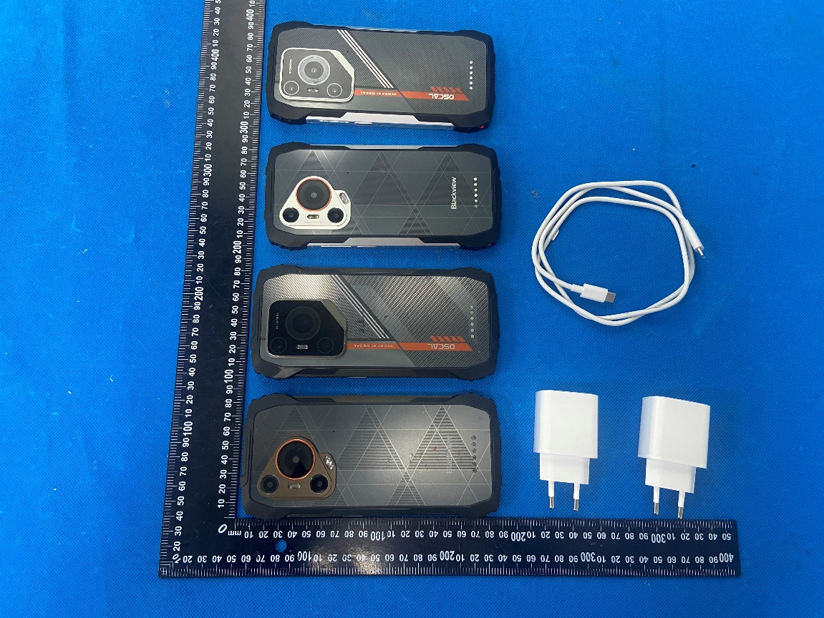
The object of the declaration described above is in conformity with the essential requirements of the relevant Union harmonization legislation: Radio Equipment Directive RED (2014/53/EU).
The following harmonized standards and technical specifications have been applied:

HEALTH & SAFETY (Art. 3(1)(a)):

EN 50360:2017+A1:2023
EN 50566:2017+A1:2023
EN 62209-1:2016
EN 62209-2:2010
EN 62479: 2010
EN IEC 62368-1:2020+A11:2020

EMC (Art. 3(1)(b)):

ETSI EN 301 489-1 V2.2.3 (2019-11)
ETSI EN 301 489-3 V2.3.2 (2023-01)
ETSI EN 301 489-17 V3.3.1 (2024-09)
ETSI EN 301 489-19 V2.2.1 (2022-09)
ETSI EN 301 489-52 V1.2.1 (2021-11)
EN 55032:2015+A1:2020
EN 55035:2017+A11:2020
EN IEC 61000-3-2:2019+A1:2021
EN 61000-3-3:2013+A2:2021

Radio Spectrum (Article 3.2):

ETSI EN 300 328 V2.2.2 (2019-07)
ETSI EN 300 328 V2.2.2 (2019-07)
ETSI EN 300 328 V2.2.2 (2019-07)
ETSI EN 301 893 V2.1.1 (2017-05)
ETSI EN 300 440 V2.2.1 (2018-07)
ETSI EN 301 511 V12.5.1 (2017-03)
ETSI EN 301 908-1 V15.2.1 (2023-01)
ETSI EN 301 908-2 V13.1.1 (2020-06)
ETSI EN 301 908-13 V13.2.1 (2022-02)
ETSI EN 301 908-25 V15.1.1 (2024-10)
ETSI EN 303 413 V1.2.1 (2021-04)
ETSI EN 303 345-1 V1.1.1 (2019-06)
ETSI EN 303 345-3 V1.1.1 (2021-06)
ETSI EN 300 330 V2.1.1 (2017-02)

The submitted samples of the above equipment has been tested and found to comply with the following European
Directives: RoHS Directive 2011/65/EU & (EU) 2015/863

NOTIFIEDBODY:

Name: LGAl Technological Center S.A. (APPLUS)

Address: Campus UAB. Ronda de la Font del Carme s/n08193 Bellaterra, Barcelona (Spain)

IdentificationNumber: 0370

EU-type examination certificate number: No. 0370-RED-11551

RF Specification:

Function | Operation Frequency | Max RF output power:
BLE | 2402MHz–2480MHz | 0.6dBm
BT(BR+EDR) | 2402MHz–2480MHz | 8.26dBm
WIFI 802.11b/g/  n(HT20/40) | 802.11b/g/n(20MHz): 2412~2472MHz;  802.11n(40MHz):2422~2462MHz | 16.22dBm
Wi-Fi  5.2G(802.11a/n20/n40/ac20/ac40/ac80) | 802.11a/ n20/ac20:5180MHz~5240MHz  802.11 n40/ac40:5190MHz~5230MHz  802.11 ac80:5210MHz | 11.7dBm
Wi-Fi  5.8G(802.11a/n20/n40/ac20/ac40/ac80) | 802.11a/ n20/ac20:5745MHz~5825MHz  802.11 n40/ac40:5755MHz~5795MHz  802.11ac80:5775MHz | 12.17dBm
GSM/GPRS/EGPRS 900 | TX(Uplink):880M‐915MHZ;  RX(Downlink):925M‐960MHZ | 33.21 dBm
GSM/GPRS/EGPRS 1800 | TX(Uplink):1710M‐1785MHZ;  RX(Downlink):1805M‐1880MHZ | 30.41 dBm
WCDMA B1 | TX(Uplink):1920-1980MHz;  RX(Downlink):2110-2170MHz | 23.25 dBm
WCDMA B8 | TX(Uplink): 880-915MHz;  RX(Downlink):925-960MHz | 22.71 dBm
LTE FDD B1 | TX(Uplink):1920-1980MHz;  RX(Downlink):2110-2170MHz | 24.06dBm
LTE FDD B3 | TX(Uplink) :1710-1785MHz;  RX(Downlink):1805-1880MHz | 24.33 dBm
LTE FDD B7 | TX(Uplink) :2500-2570MHz;  RX(Downlink):2620-2690MHz | 24.29dBm
LTE FDD B8 | TX(Uplink): 880MHz to 915 MHz  RX(Downlink): 925 MHz to 960 MHz | 24.24dBm
LTE FDD B20 | TX(Uplink): 832MHz~862MHz;  RX(Downlink):791MHz~821MHz | 24.28 dBm
LTE FDD B28 | TX(Uplink): 703 MHz to 748MHz  RX(Downlink): 758 MHz to 803 MHz | 24.41 dBm
LTE TDD B40 | Uplink & Downlink: 2300 MHz to 2400 MHz | 22.79 dBm
LTE TDD B41 | Uplink & Downlink: 2496 MHz to 2690 MHz | 26.54 dBm
NR FDD n1: | Uplink: 1920 MHz to 1980MHz  Downlink: 2110 MHz to 2170 MHz | 24.28 dBm
NR FDD n3: | Uplink: 1710 MHz to 1785 MHz  Downlink: 1805 MHz to 1880 MHz | 24.1dBm
NR FDD n8: | Uplink: 880 MHz to 915 MHz  Downlink: 925 MHz to 960 MHz | 23.92 dBm
NR FDD n20: | Uplink: 832 MHz to 862 MHz  Downlink: 791 MHz to 821 MHz | 23.97 dBm
NR FDD n28: | Uplink: 703 MHz to 748 MHz  Downlink: 758 MHz to 803 MHz | 23.29 dBm
NR TDD n40: | Uplink & Downlink: 2300 MHz to 2400 MHz | 24.37 dBm
NR TDD n41: | Uplink & Downlink: 2496 MHz to 2690 MHz | 27.95 dBm
NR TDD n77: | Uplink & Downlink: 3300 MHz to 4200 MHz | 27.59 dBm
NR TDD n78 | Uplink & Downlink: 3300 MHz to 3800 MHz | 27.5 dBm
NFC | 13.56MHz | 11.16 dBuA/m@10m
FM | Rx(Downlink): 87.5MHz~108MHz | --
GPS | Rx(Downlink): 1.57542GHz | --

Tests for SAR are conducted using standard operating positions with the device transmitting at its

highest certified power level in all tested frequency bands. The maximum SAR values tested on this device when used in its normal position at the ear and when used closet othe body(at a minimum distance of 5mm/0mm) are:

Max SAR Value(W/kg)  Limit is 2.0(W/kg) for 10-g | 10-g Head | 1.360W/kg
Max SAR Value(W/kg)  Limit is 2.0(W/kg) for 10-g | 10-g Body | 1.004W/kg
Limit is 4.0(W/kg) for 10-g | 10-g Member DAS | 2.415W/kg

Technical file held by: Shenzhen Doke Electronic Co., LTD
Address: 801, Building3, 7th Industrial Zone, Yulv Community, Yutang Road, Guangming District,
Shenzhen, China

Signed for and on behalf of: Shenzhen Doke Electronic Co., Ltd
Name and Title: | zhang.liuwei /Manager
Address: | 801, Building3, 7th Industrial Zone, Yulv Community, Yutang Road, Guangming District, Shenzhen, China.



Signature of Authorized Person
2026-5-14

